Assignment 01

Team 44

Name- Samsul Alam Niom

ID-1620075042

Course Code CSE 231.L

Section- 04

Let,

Study Table=A

Couches = B

Shelf= C

Desk= D

|  |  |  |  |  |  |
| --- | --- | --- | --- | --- | --- |
| A | B | C | D | X | Min Term |
| 0 | 0 | 0 | 0 | 0 |  |
| 0 | 0 | 0 | 1 | 0 |  |
| 0 | 0 | 1 | 0 | 0 |  |
| 0 | 0 | 1 | 1 | 1 |  |
| 0 | 1 | 0 | 0 | 0 |  |
| 0 | 1 | 0 | 1 | 1 |  |
| 0 | 1 | 1 | 0 | 0 |  |
| 0 | 1 | 1 | 1 | 0 |  |
| 1 | 0 | 0 | 0 | 0 |  |
| 1 | 0 | 0 | 1 | 1 |  |
| 1 | 0 | 1 | 0 | 0 |  |
| 1 | 0 | 1 | 1 | 0 |  |
| 1 | 1 | 0 | 0 | 0 |  |
| 1 | 1 | 0 | 1 | 0 |  |
| 1 | 1 | 1 | 0 | 0 |  |
| 1 | 1 | 1 | 1 | 0 |  |

Here We Find, Min Term= Y(A,B,C,D) =∑m (3,5,9)

By using K Map We Find,

CD 00 01 11 10

|  |  |  |  |  |
| --- | --- | --- | --- | --- |
| AB |  |  |  |  |
| 00 | 0 m0 | 0 m1 | 1 m3 | 0 m2 |
| 01 | 0 m4 | 1 m5 | 0 m7 | 0 m6 |
| 11 | 0 m12 | 0 m13 | 0 m15 | 0 m14 |
| 00 | 0 m8 | 1 m9 | 0 m11 | 0 m10 |

From This K Map, we get,

F = I+II+III

= A’B’CD+A’BC’D+AB’C’D

=D (A’B’C+A’BC’+AB’C’)

Logisim Diagram

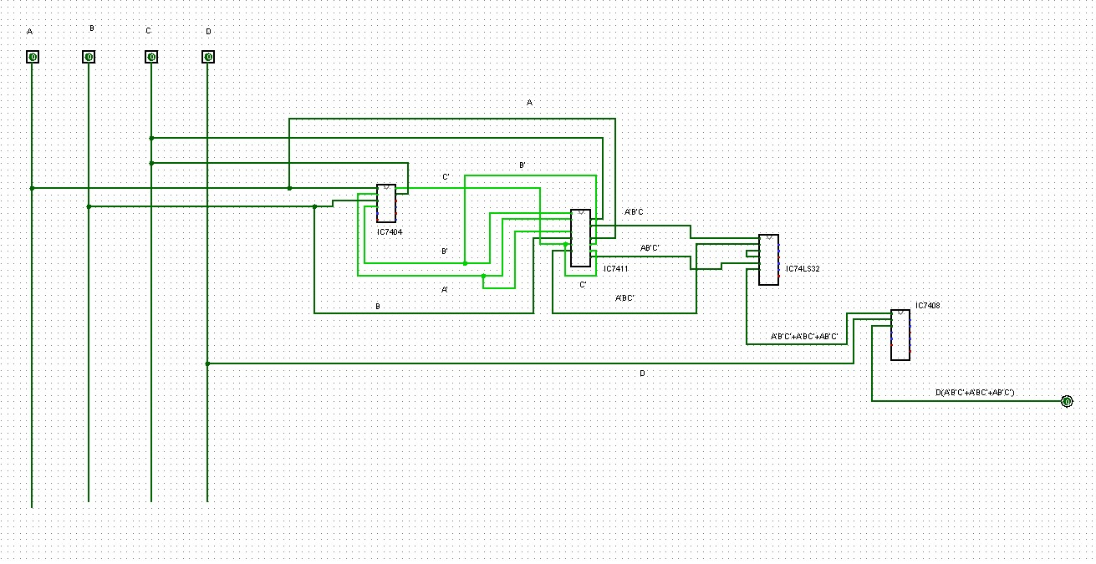

Draft Report:- Here I make the truth table based on the question. After that, I used a k map to find the equation. Then I implemented the equation in Logisim.